# NoSQL Use Cases Across Industries

**1. What is NoSQL?**

**NoSQL (Not Only SQL)** refers to a class of database systems designed to handle **unstructured, semi-structured, or rapidly changing data**. Unlike SQL, which uses a rigid relational schema, NoSQL databases are schema-flexible and horizontally scalable.

**Types of NoSQL databases**:

* **Document stores** (MongoDB, Couchbase) → JSON-like docs.
* **Key-Value stores** (Redis, DynamoDB) → ultra-fast lookups.
* **Wide-column stores** (Cassandra, ScyllaDB) → scalable, time-series/event data.
* **Graph databases** (Neo4j, Amazon Neptune) → relationships & networks.

**2. Why NoSQL is used**

* **Scalability**: Easily handle millions/billions of records by distributing across servers.
* **Flexibility**: No fixed schema → supports fast-evolving applications.
* **Performance**: High throughput and low latency for real-time workloads.
* **Variety of data**: Handles structured + unstructured (text, JSON, logs, images).
* **Polyglot persistence**: Different NoSQL types for different use cases (document for catalogs, graph for relationships, etc.).

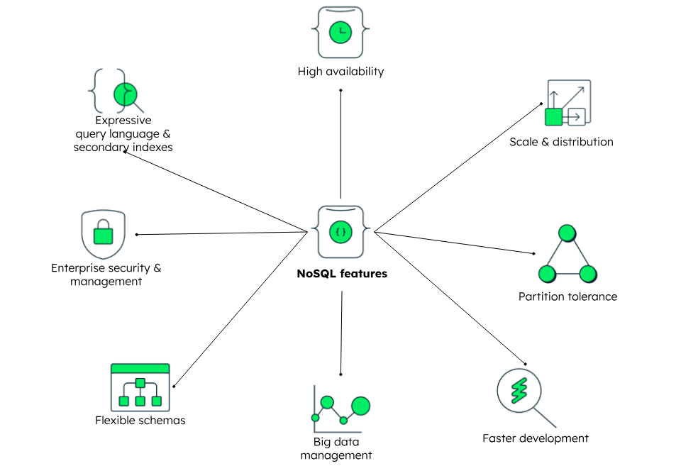

**REAL WORLD USES CASES IN INDUSTRIES**

**1. Retail Industry**

**Challenges with SQL**

* Product catalogs are highly dynamic (new attributes daily: colors, discounts, brands).
* SQL schema changes are costly → schema rigidity leads to slow rollouts.
* High read/write demand during flash sales or festive shopping events.

**NoSQL Use Cases**

1. **Product Catalog Management (Document DBs like MongoDB, Couchbase)**
   * Flexible schema stores product attributes in JSON.
   * Easily handle products with unique attributes without altering tables.
   * Example: eBay, Walmart use NoSQL to manage millions of items with different attributes.
2. **Shopping Cart and Session Management (Key-Value Stores like Redis, DynamoDB)**
   * Every cart is temporary, requires ultra-fast updates.
   * SQL row locking causes bottlenecks; Key-Value stores ensure microsecond retrieval.
3. **Inventory Management & Order Tracking (Wide-Column Stores like Cassandra)**
   * Ensures stock levels update across warehouses in real time.
   * Helps avoid “out-of-stock” errors and optimizes logistics.
4. **Personalized Recommendations (Graph DB + Document DB)**
   * Captures relationships between customers, purchases, and trends.
   * Example: Amazon’s “People who bought this also bought”.

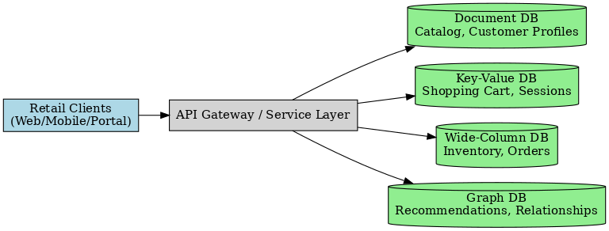

NoSQL DB Architecture for Retail Industry

**2. Education Industry**

**Challenges with SQL**

* Growing demand for adaptive learning.
* SQL doesn’t scale well with student activity logs (millions of events daily).
* Course materials are often unstructured (videos, PDFs).

**NoSQL Use Cases**

1. **Content Storage (Document DBs like MongoDB)**
   * Store large multimedia course content (videos, lecture notes, assignments).
   * Allows versioning of materials without schema changes.
2. **Adaptive Learning Paths (Graph DB like Neo4j)**
   * Links concepts, prerequisites, and outcomes.
   * Helps suggest next courses/chapters to students based on performance.
   * Example: Coursera & Khan Academy use knowledge graphs for adaptive recommendations.
3. **Student Activity Tracking (Time-Series DBs like InfluxDB, Cassandra)**
   * Logs time spent on lessons, quiz results, and interactions.
   * Useful for analytics dashboards for teachers and institutions.
4. **Collaboration & Real-Time Chat (Key-Value DBs)**
   * Supports group projects, instant messaging, discussion boards.

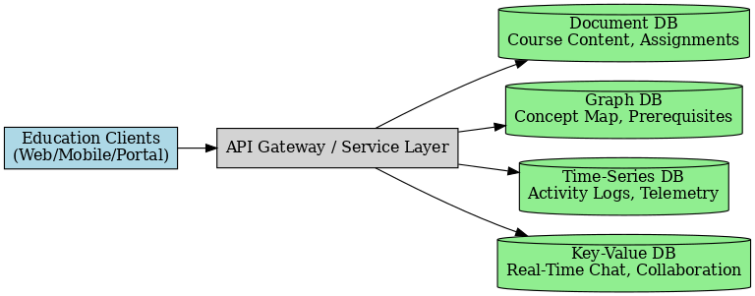

NoSQL DB Architecture for Education Industry

**3. Banking Industry**

**Challenges with SQL**

* SQL is **ACID**-compliant (great for ledgers) but not real-time scalable for fraud detection or event streaming.
* Complex joins for fraud detection → slow queries.

**NoSQL Use Cases**

1. **Fraud Detection (Graph DB like Neo4j, TigerGraph)**
   * Detects unusual money transfers by analyzing patterns & relationships.
   * Example: Identifies if a user suddenly transacts with multiple suspicious accounts.
2. **Real-Time Transaction Logging (Wide-Column DB like ScyllaDB, Cassandra)**
   * Captures millions of financial events per second.
   * Used for real-time auditing, alerts, and anomaly detection.
3. **Customer 360 Profiles (Document DBs)**
   * Aggregates demographic + behavioral + financial data.
   * Helps banks personalize offers (loans, investments).
   * Example: Capital One uses NoSQL to analyze customer profiles.
4. **Digital Banking Session Management (Key-Value DB like Redis)**
   * Manages millions of concurrent mobile logins.
   * Prevents session conflicts and ensures low-latency authentication.

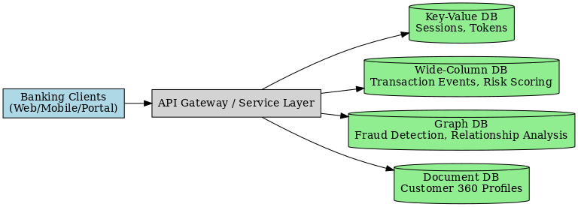

NoSQL for Education Banking Industry

**4. Social Media Industry**

**Challenges with SQL**

* Billions of users, millions of concurrent requests.
* SQL joins for posts, likes, and followers → performance bottlenecks.

**NoSQL Use Cases**

1. **User-Generated Content (Document DBs like MongoDB, Couchbase)**
   * Posts, comments, metadata stored as documents.
   * Schema-less → supports new features (e.g., Stories, Reels) without schema redesign.
2. **Social Graphs (Graph DB like Neo4j, Amazon Neptune)**
   * Manages friends, followers, likes, relationships.
   * Enables fast queries: *“Who are my friends’ friends that liked this post?”*.
   * Example: Facebook Graph API.
3. **Real-Time Feed & Notifications (Key-Value DBs like Redis, DynamoDB)**
   * Pushes live notifications with sub-millisecond latency.
   * Supports personalized feeds for millions of users simultaneously.
4. **Media Metadata & Analytics (Wide-Column DBs)**
   * Stores metadata of billions of images/videos.
   * Supports engagement analytics (likes, shares, impressions).

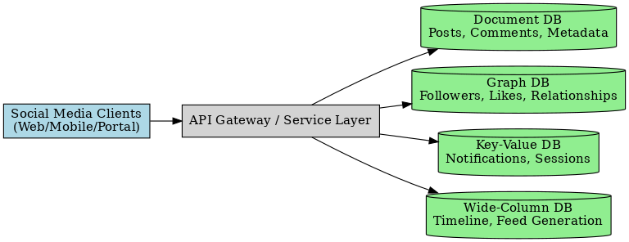

NoSQL Architecture for Social Media Industry